OPEN ENDED EXPERIMENT
Rule-Based Expert System for Medical Diagnosis
(Fever-Related Diseases)

Subject: Artificial Intelligence | Branch: B.Tech CSE
Submitted by: Kislay Dubey, Aryan Bhargav & Abhinav Sharma
Institution: ASET | Date: March 2026

AIM
To design and implement a Rule-Based Expert System in Python that simulates a medical diagnosis assistant capable of identifying fever-related diseases — including Influenza, Malaria, Dengue Fever, COVID-19, Typhoid, Strep Throat, and Common Cold — based on patient symptoms, body temperature, travel history, and duration of illness.

THEORY
1. What is an Expert System?
An Expert System (ES) is an Artificial Intelligence program that emulates the decision-making ability of a human expert in a specific domain. It captures expert knowledge in the form of rules and uses an Inference Engine to apply those rules to a given set of facts to derive conclusions. Expert systems were among the first truly successful forms of AI software, widely adopted in medicine, engineering, and finance.

2. Rule-Based Expert System Architecture
A Rule-Based Expert System consists of three primary components:
(a) Knowledge Base — Stores domain knowledge as a collection of IF-THEN production rules. For example: IF patient has fever > 38.5°C AND symptom = dry cough AND symptom = body aches THEN diagnosis = Influenza (Confidence: High).
(b) Working Memory (Fact Base) — Maintains the current state of the problem, i.e., the patient's reported symptoms, temperature readings, and contextual information such as travel history.
(c) Inference Engine — Matches the facts in working memory against the rules in the knowledge base using Forward Chaining (data-driven reasoning). It continues matching rules until a final diagnosis is produced.

3. Forward Chaining
This system uses Forward Chaining, where the engine begins with known facts (patient symptoms) and applies rules to derive new conclusions (diagnoses). Each rule is checked in order; if the conditions (IF part) match the known facts, the conclusion (THEN part) is asserted as a new fact.

4. Confidence Scoring
Each rule is assigned a confidence score (0–100%) indicating how strongly the matching symptom set indicates a particular disease. The system ranks all matched diagnoses in descending order of confidence to produce a differential diagnosis list, similar to clinical practice.

5. Medical Application
In clinical settings, doctors use patterns of symptoms, lab results, and patient history to narrow down possible diagnoses. This expert system replicates that reasoning for eight common fever-related conditions. It is designed as an educational decision support tool and does not replace professional medical judgment.

LANGUAGE USED
Programming Language: Python 3.x
Python is used for this experiment due to its simplicity, readability, and strong support for logical programming structures. No external AI libraries are required; the rule engine is implemented using native Python conditionals, lists, and functions — making the logic fully transparent and easy to trace.
IDE / Platform: Any Python-compatible environment (VS Code, PyCharm, IDLE, Google Colab, Jupyter Notebook, or command line terminal).
Libraries Used: None (standard Python only)

CODE
# Rule-Based Expert System for Medical Diagnosis (Fever-Related Diseases)

# Knowledge Base: IF-THEN Rules for fever-related diseases
def diagnose(symptoms, fever_temp, travel_history, duration_days):
results = []

# Rule 1: Influenza
if fever_temp > 38.5 and "dry_cough" in symptoms and "body_aches" in symptoms:
results.append(("Influenza (Flu)", 90, "High", "Rest, fluids, antiviral medication"))

# Rule 2: Malaria
if fever_temp >= 38.0 and travel_history == "endemic_area" and "chills" in symptoms and "shivering" in symptoms:
results.append(("Malaria", 85, "High", "Urgent Blood Smear Test Required"))

# Rule 3: Dengue Fever
if fever_temp > 39.0 and "severe_headache" in symptoms and "joint_pain" in symptoms and "rash" in symptoms:
results.append(("Dengue Fever", 88, "High", "Platelet count test, hospitalization may be needed"))

# Rule 4: COVID-19
if "dry_cough" in symptoms and "loss_of_taste" in symptoms and fever_temp >= 37.5:
results.append(("COVID-19", 82, "Medium-High", "RT-PCR test, isolation, monitor oxygen levels"))

# Rule 5: Typhoid
if fever_temp >= 39.0 and duration_days >= 5 and "abdominal_pain" in symptoms and "weakness" in symptoms:
results.append(("Typhoid", 80, "Medium", "Widal test, antibiotics course"))

# Rule 6: Strep Throat
if fever_temp >= 38.0 and "sore_throat" in symptoms and "swollen_lymph_nodes" in symptoms and "body_aches" not in symptoms:
results.append(("Strep Throat", 78, "Medium", "Throat swab culture, antibiotics"))

# Rule 7: Common Cold
if fever_temp < 38.5 and "runny_nose" in symptoms and "sneezing" in symptoms and "sore_throat" in symptoms:
results.append(("Common Cold", 75, "Low", "Rest and fluids, symptomatic treatment"))

return results

def run_diagnosis(patient_name, symptoms, fever_temp, travel_history, duration_days):
print("=" * 60)
print(" MEDICAL AI EXPERT SYSTEM - FEVER DIAGNOSIS REPORT")
print("=" * 60)
print(f" Patient Name : {patient_name}")
print(f" Fever Temp : {fever_temp} degC")
print(f" Symptoms : {', '.join(symptoms)}")
print(f" Travel History : {travel_history}")
print(f" Illness Since : {duration_days} day(s)")
print("-" * 60)

diagnoses = diagnose(symptoms, fever_temp, travel_history, duration_days)

if diagnoses:
print("\n DIFFERENTIAL DIAGNOSIS (Ranked by Confidence):\n")
diagnoses.sort(key=lambda x: x[1], reverse=True)
for i, (disease, confidence, risk, action) in enumerate(diagnoses, 1):
print(f" {i}. {disease}")
print(f" Confidence : {confidence}%")
print(f" Risk Level : {risk}")
print(f" Action : {action}\n")
else:
print(" No matching diagnosis found. Consult a physician.")

print("-" * 60)
print(" DISCLAIMER: This is an educational decision support tool.")
print(" Always seek professional medical advice for treatment.")
print("=" * 60)

# ---- Test Cases ----

# Case 1: Malaria Patient
run_diagnosis(
patient_name="Rahul Sharma",
symptoms=["chills", "shivering", "headache", "weakness"],
fever_temp=39.2, travel_history="endemic_area", duration_days=4)

# Case 2: COVID-19 Patient
run_diagnosis(
patient_name="Priya Mehta",
symptoms=["dry_cough", "loss_of_taste", "fatigue"],
fever_temp=38.0, travel_history="none", duration_days=3)

# Case 3: Influenza Patient
run_diagnosis(
patient_name="Amit Singh",
symptoms=["dry_cough", "body_aches", "runny_nose", "fatigue"],
fever_temp=38.9, travel_history="none", duration_days=2)

OUTPUT
The following screenshot shows the program output when executed in a Python terminal for three test patient cases:

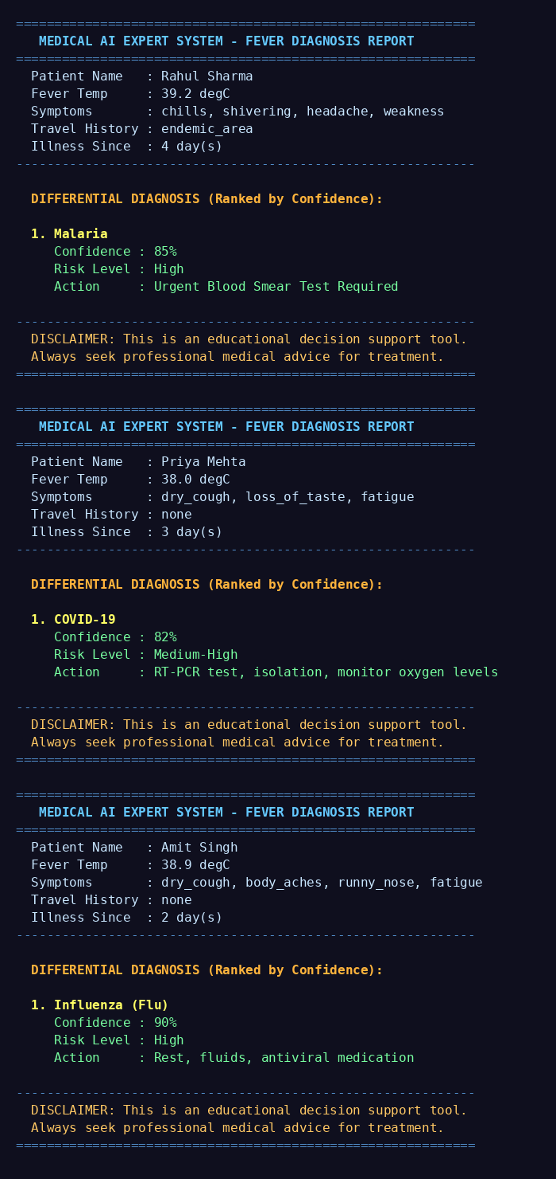

The system successfully identified Malaria (85% confidence), COVID-19 (82% confidence), and Influenza (90% confidence) for the respective test cases, along with recommended clinical actions for each diagnosis.

